GESTURE CONTROLLER FOR HOME AUTOMATION

A PROJECT REPORT

Submitted by

K.M.MAHENDRAN (111513107045)
BHARADWAJ CHENNURU (111513107014)
A.NAGA PHANINDRA (111513107005)
I.DINESH (111513107027)

In partial fulfillment for the award of the degree

Of

BACHELOR OF ENGINEERING

IN

ELECTRONIC AND INSTRUMENTATION ENGINEERING


RMD engineering college, Chennai

ANNA UNIVERSITY:: CHENNAI 600 025

APRIL 2017

ANNA UNIVERSITY::CHENNAI 600 025

BONAFIDE CERTIFICATE

Certified that this project report “GESTURE CONTROLLER FOR HOME AUTOMATION” is the bonafide work of “K.M.MAHENDRAN, BHARATHWAJ CHENNURU, A.NAGA PHANINDRA, I.DINESH” who carried out the project work under my supervision.

SIGNATURE SIGNATURE
Dr.A.CHILAMBUCHELVAN Ph.D Dr.G. NALINASHINI M.E, Ph.D
HEAD OF THE DEPARTMENT, ASSOCIATE PROFESSOR,
Electronics and Instrumentation Electronics and Instrumentation
Engineering, Engineering,
RMD Engineering College RMD Engineering College
Kavaraipettai, Kavaraipettai,
Chennai – 601206. Chennai – 601206.

Submitted for the ANNA UNIVERSITY Examination held on _________________

INTERNAL EXAMINER EXTERNAL EXAMINER

ACKNOWLEDGEMENT

A project of this magnitude and nature requires the kind co-operation and support from many, for successful completion. I wish to express my sincere thanks to all those who were involved in the completion of this project.

It is my immense pleasure to express my deep sense of gratitude to our chairman Thiru R.S.MUNIRATHNAM, our vice chairman Thiru R.M.KISHORE and our director Thiru R.JOTHI NAIDU, for the facilities and support given by them in the college.

I am extremely thankful to our principal Dr.K.SIVARAM Ph.D., for having given us an opportunity to serve the purpose of any education.

I am indebted to Dr.A.CHILAMBUCHELVAN Ph.D., Head of the Department of Electronics & Instrumentation Engineering, for his valuable guidance and useful suggestions during the course of the project.

I am are very thankful to our project coordinator Ms. M. Divya Devi M.E., Assistant Professor in the Department of Electronics and Instrumentation Engineering, for her valuable suggestions and guidance for completion of this project on time.

I extend our sincere thanks and gratitude to our project guide Dr.G. NALINASHINI M.E(Ph.D), Assistant Professor/Associate Professor in the department of electronics & Instrumentation Engineering for providing the necessary literature, guidance and constant encouragement for successful completion of this Project.

Last but not the least, I wish to thank all the teaching and non-teaching staff of Electronics & Instrumentation Department, for their blessings and for their constant support throughout our dissertation.

TABLE OF CONTENT
CHAPTER NO TITLE PAGE NO LIST OF FIGURES 6
LIST OF ABBREVATIONS 6
ABSTRACT 7
- INTRODUCTION 8
  - PROJECT INTRODUCTION 8
1.2 HARDWARE COMPONENTS 11
1.3 SOFTWARE COMPONENTS 11
2 LITERATURE SURVEY 12

3 PROPOSED SYSTEM 17
3.1 Framework and algorithm overview 17
3.2 Object Range Detection 19
3.3 Automatic Gesture Recognition 20
3.3.1 Static and Dynamic Gestures Recognition 20
3.3.2 Distribution of Edge Pixels 21
3.3.3 Gesture Recognition 22

4 PROJECT DESCRIPTION 24
4.1 Block Diagram 24
4.2 Power Supply Source 24
4.3 Regulated Power Supply 26
4.4 Camera 27
4.5 CSI 29
4.6 Secure Digital (SD) 30
4.7 Relay Module 31
4.8 Household Gadgets 31

5 RASPBERRY PI 32
5.1 INTRODUCTION 32
5.2 HARDWARE 34
5.2.1 Processor 34
5.2.2 RAM 35
5.2.3 Peripherals 35
5.2.4 Networking 35
5.2.5 Over Clocking 36
5.2.6 Video 36
5.2.7 Real Time Clock 36
5.3 SOFTWARE 37
5.3.1 Operating System 37
5.3.2 OpenCV 37
5.3.3 Python 38

6 OPERATING SYSTEM 39
6.1 Raspbian OS 39
6.2 Raspberry Pi Config.txt Options 39
6.3 Raspberry Pi SD Cards Performance 40
6.3.1 Instructions 41

7 RESULT 42

8 CONCLUSION 43
9 FUTURE SCOPE 44
10 REFERENCE 45
LIST OF FIGURES
No. TITLE PAGE No.
1.1 Gesture Workflow 11
3.1 Flowchart of Proposed System 18
3.3 Different Gesture Recognition 20
3.3.3 Gesture Recognition Algorithm Flowchart 22
4.1.1 Block Diagram 24
4.2.1 Power Supply 24
4.3.1 Power Supply Source 24
4.4.1 PI Camera 27
4.4.2 Camera Interfacing with Controller 28
4.7 Relay Module 31
4.8 Household Gadgets 31
7. Result Of Project 42

LIST OF ABBREVATIONS
OPENCV Open Source Computer Vision Library
HDMI high-Definition Multimedia Interface
ROI Region Of Interest
LoG Laplacian Of Gaussian
CAMSHIFT Continuously Adaptive Mean Shift

ABSTRACT
The camera-based gesture recognition controller to help blind persons manipulate every house hold gadgets with each gesture as designed in this project. In our home, each gadget can be toggled by waving gesture in-front of a camera for Computer Vision. To recognize the gestures from cluttered backgrounds or other surrounding objects in the camera view, The efficient and effective motion based method to define a region of interest (ROI) in the video by asking the user to make gestures is proposed. This method extracts the gesture from the region of interest by Laplacian of Gaussians (LoG) background subtraction method. In the extracted ROI, gesture recognition is conducted to acquire gesture to toggle the gadget that corresponds to the gesture given. Gestures in the localized regions are then digitized and recognized by off-the-shelf optical character recognition software.
The recognized gesture codes are output to blind users to manipulate each gadget in the house. The edges of a gesture are obtained by LoG to count each finger in the gesture for manipulating the gadgets in the house.
The edge detection is done by:
- Applying LoG to the image.
- Detection of zero-crossings in the image.
- Threshold the zero-crossings to keep only those strong ones (large difference between the positive maximum and the negative minimum).

CHAPTER I
INTRODUCTION
1.1 PROJECT INTRODUCTION
Recent developments in computer vision, digital cameras, and portable computers make it feasible to assist these individuals by developing camera-based products that combine computer vision technology with other existing commercial products such Optical Flow Gesture recognition (OFGR) systems.

Gesture are part of a sequential action of our hand and we use gesture to signify something to someone or use it manipulate something. The gestures are used for various purposes. The blind can use gesture as they can’t see the world and would feel depressed about to search for the switch in the room and have to search for a while. But, to use gesture as a toggle mechanism in homes and industries for better automation of our Environment as it would make our life comfortable and make us at ease.

The ability of people who are blind or have significant visual impairments to do their own chores at home and in any environment, which will enhance independent living and foster economic and social self-sufficiency. Today, there are already a few systems that have some promise for portable use, but they cannot handle toggling of devices in the house. For example, people who are blind or physically impaired find it difficult to do their own work and would have to rely on someone to do their chores. If they had an automated home that would toggle gadgets with each gesture by the user, It would make his life at ease.

Gestures technology is used in many fields like in televisions that could use gestures to change channels and volume, In Smartphones that could use gesture with camera to play games or control home appliances, Gesture controlled robotic arm or wheel chair, and even gesture recognized Encryption.

However, the gesture to be read must be procured on a clear, dark background for better recognition. The Computer Vision is a useful tool for image processing and Furthermore, it helps in Machine Learning and Deep Learning Purposes. These systems require a blind user to manually localize areas of interest for gesture recognition. The gestures are to be prerecorded and stored as a database for recognition by applying the Continuously Adaptive Mean Shift (CAMSHIFT) Algorithm.

To assist blind persons to control the gadgets in the house, we have conceived of a camera-gesture recognition framework to track the object of interest within the camera view and extract each gesture from the Environment.

Our proposed algorithm can effectively handle complex background and multiple patterns, and extract text information from both hand-held objects and nearby signage, Incase of assistive home automation for blind persons, it is very challenging for users to position the object of interest within the center of the camera’s view. As of now, there are still no acceptable solutions.

We approach the problem in stages. To make sure the hand-held object appears in the camera view, we use a camera with sufficiently wide angle to accommodate users with only approximate aim. This may often result in other gesture appearing in the camera’s view (for example, individual’s gestures would interrupt the process). To extract the hand-held object from the camera image, we develop a motion-based method to obtain a region of interest (ROI) of the object.

Then, we perform gesture recognition only in this ROI. It is a challenging problem to automatically localize objects and gesture ROIs from captured images with complex backgrounds, because gestures in captured images is most likely surrounded by various background outliners “noise,”.

We divide them into two categories: rule-based and learning-based. Rule-based algorithms apply pixel-level image processing to extract gestures from predefined edge detection. Edge pixel density with the Laplacian operator and employed maximum gradient differences to identify gestures, Incase of color-based strips segmentation is performed through a Gaussian mixture model for calculating a confidence value for the ROI.

Learning-based algorithms, on the other hand, model gestures and extract representative signs to build gesture classifiers. In solving the task at hand, to extract gestures from complex backgrounds with multiple and variable hand patterns.
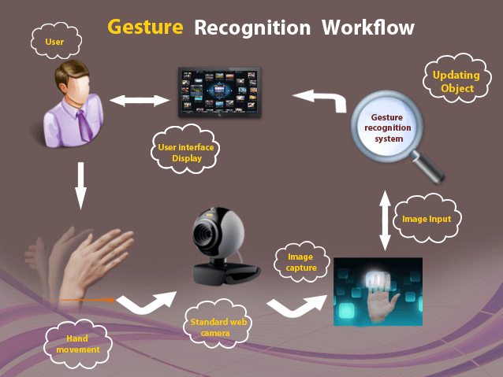
Fig 1.1 Gesture workflow

1.2 HARDWARE COMPONENTS
- Raspberry Pi.
- 8 Channel Relay Module.
- Pi cam.
- SD Card.
- Jumper wires.
- AC Motor.
- Electric Bulb.
- Electric Fan.
- Solenoid Lock.
- Power Supply.
1.3 SOFTWARE COMPONENTS
- Raspbian OS- Jessie.
- OpenCV.
- Python.
CHAPTER II
LITERATURE SURVEY

- P. Garg, N. Aggarwal and S. Sofat. (2009). “Vision Based Hand Gesture Recognition,” World Academy of Science, Engineering and Technology, Vol. 49, pp. 972-977.

Various techniques and tools are applied for recognition hand gesture; in this section some of these methods are presented hereinafter. Recognized hand gestures using fuzzy c-means clustering algorithm for mobile remote application. The input image is converted into HSV color space and segmented using Threshold technique. After removing the noise from the image, 13 elements were extracted as the feature vector, first element represents the aspect ratio of the bounding box of the hand, and the rest 12 parameters represent grid cells of the image. Each cell represents the mean gray level in the 3 by 4 block partition of the image, where the mean value of each cell is the average brightness of these pixels, FCM clustering algorithm used for classification gestures. The system implemented under intricate background and invariant light conditions. The system trained with 120 samples, 20 samples for 6 gestures. The system implemented with recognition accuracy of 85.83% and recognition time 2-4 seconds. Hasan partitioned the input image into different blocks of 23x23 pixels each, and used these blocks as a features vector. The system consists of training phase, and running phase. In training phase, several feature vectors of input gestures has been stored in a database. In testing phase the input image features vector compared with those stored in the database for classification using Euclidean distance. Since segmentation operation is imperfect, hand saturation algorithm was applied for filling the inner area of the hand gestures.

2. Automatic detection and recognition of signs from natural scenes

In this paper, we present an approach to automatic detection and recognition of signs from natural scenes, and its application to a sign translation task. The proposed approach embeds multi-resolution and multi-scale edge detection, adaptive searching, color analysis, and affine rectification in a hierarchical framework for sign detection, with different emphases at each phase to handle the different hand signs, orientations, color distributions and backgrounds. We use affine rectification to recover deformation of the ROI caused by an inappropriate camera view angle.
The procedure can significantly improve gesture detection rate and optical character recognition (OCR) accuracy. Instead of using binary information for OCR, we extract features from an intensity image directly.
We propose a local intensity normalization method to effectively handle lighting variations, followed by a Gabor transform to obtain local features, and finally a linear discriminant analysis (LDA) method for feature selection.

3. Wearable Obstacle Avoidance Electronic Travel Aids for Blind: A Survey
The last decades a variety of portable or wearable navigation systems have been developed to assist visually impaired people during navigation in known or unknown, indoor or outdoor environments. There are three main categories of these systems: electronic travel aids (ETAs), electronic orientation aids (EOAs), and position locator devices (PLDs). This paper presents a comparative survey among portable/wearable obstacle detection/avoidance systems (a subcategory of ETAs) in an effort to inform the research community and users about the capabilities of these systems and about the progress in assistive technology for visually impaired people. The survey is based on various features and performance parameters of the systems that classify them in categories, giving qualitative-quantitative measures. Finally, it offers a ranking, which will serve only as a reference point and not as a critique on these systems.

4. Color-based approach for hand gestures in images using support vector machines and continuously adaptive mean shift algorithm
The current paper presents a novel texture-based method for detecting gestures in images. A support vector machine (SVM) is used to analyze the color properties of gestures. No external texture feature extraction module is used, but rather the intensities of the raw pixels that make up the color pattern are fed directly to the SVM, which works well even in high-dimensional spaces. Next, ROI are identified by applying a continuously adaptive mean shift algorithm (CAMSHIFT) to the results of the color analysis.
The combination of CAMSHIFT and SVMs produces both robust and efficient gesture recognition, as time-consuming color analyses for less relevant pixels are restricted, leaving only a small part of the input image to be analyzed.

5. A Wearable Head- Mounted Sensor Based Apparatus for Eye Tracking Applications” IEEE International Conference on Virtual Environments, Human-Computer Interfaces, and Measurement Systems Istanbul, Turkey, dated 14-16 July 2008

When an unfortunate event affects the motor capacity of a person, it is necessary to use devices like wheelchairs that offer a means of displacement for patients with motors problems of the lower limbs. Tremendous leaps have been made in the field of wheelchair technology. However, even these significant advances haven’t been able to help quadriplegics navigate wheelchair unassisted. Some patients that cannot manipulate the wheelchair with their arms due to a lack of force or psychomotor problems in the superior members, request electric wheelchairs, frequently manipulated with joysticks; however the joystick manipulation is even not practical and frequently it must be handle with the mouth. The present article presents the partial results in the development of a wheelchair controlled by an intuitive interface, where the instructions are given by hand gesture instructions. The advances are presented in the realization of the control software using a Webcam and some distances and presence sensors controlled by a PIC microcontroller that establishes the communication with a program developed in Lab view. This paper is inspired from an IEEE Research Paper Titled „A Wearable Head- Mounted Sensor Based Apparatus for Eye Tracking Applications‟ that was presented in the IEEE International Conference on Virtual Environments, Human-Computer Interfaces, and Measurement Systems Istanbul, Turkey, dated 14-16 July 2008. The above paper approach was dealing with wheelchair control using eye ball movement with slight modification to it. Our paper deals with the control of wheelchair motion by hand gesture.

6. Pei Jia, Huosheng H Hu, Tao Lu Kui Yuan, Head gesture recognition for hands-free control of an intelligent wheelchair
A robust head gesture‐based interface (HGI), is designed for head gesture recognition of the Wheel Chair user. The recognized gestures are used to generate motion control commands to the low‐level DSP motion controller so that it can control the motion of the wheelchair according to the user's intention. Adaboost face detection algorithm and Camshift object tracking algorithm are combined in our system to achieve accurate face detection, tracking and gesture recognition in real time. It is intended to be used as a human‐friendly interface for elderly and disabled people to operate our intelligent wheelchair using their head gestures rather than their hands.

CHAPTER 3
PROPOSED SYSTEM

3.1. FRAMEWORK AND ALGORITHM OVERVIEW
This paper presents a prototype system of gesture Recognition. As illustrated the system framework consists of three functional components: scene capture, image processing and toggle of gadgets. The scene capture component collects scenes containing objects of interest in the form of images or video. In our prototype, it corresponds to a camera attached to the USB of the Raspberry Pi.

The data processing component is used for deploying our proposed algorithms, including 1) object-of-interest detection to selectively extract the image of the object held by the blind user from the cluttered background or other neutral objects in the camera view; and 2) Gesture obtained from image regions containing hand signs, and edge detection to transform image-based signs information into readable codes. We use Raspberry Pi as the processing device in our current prototype system.

The output component is used to control the gadgets in the house. A Relay Board with gadgets connected is the output of the setup. This simple hardware configuration ensures the portability of the gesture recognition that depicts a work flowchart of the prototype system as shown. A frame sequence is captured by a camera worn by blind users, containing their hand-gestures and cluttered background.

To extract gestures from the Region of Interest, motion based object detection is first applied to determine the user’s object of interest by waving signs, while recording video ground from motion-based object detection, and the image represents the calculated foreground object at each frame. The object of interest is localized by the average of foreground masks.

Next, our novel proposed algorithm is applied to the object of interest to extract gestures. At first, ROI are generated by layout analysis of color uniformity and horizontal alignment. After that, off-the-shelf OCR is employed to perform gesture recognition in the localized regions. The recognized gestures would contribute to each device in the house and provide a toggle to the respective gadgets with each gesture waved in-front of the camera.

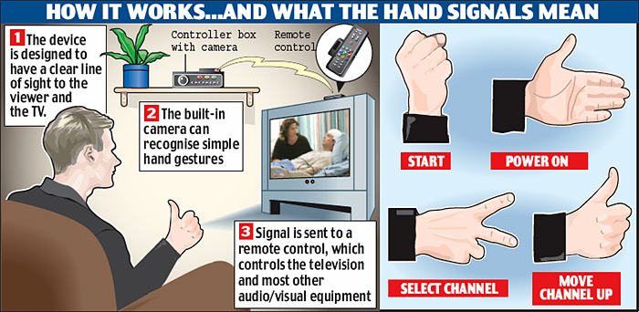
Fig: 3.1. Flowchart of the proposed framework to procure gestures to toggle gadgets for blind users.

Our main contributions embodied in this prototype system are a novel motion-based algorithm to solve the aiming problem for blind users by their simply shaking the object of interest for a brief period.
2) A novel algorithm of automatic localization to extract regions from complex background and multiple hand sign patterns, and
3) A portable camera-based assistive framework to aid blind persons to make gestures to automate their gadgets at home. Algorithms of the proposed system are evaluated over images captured by blind users using the described techniques.

3.2. OBJECT REGION DETECTION:
To ensure that the hand-held object appears in the camera view, we employ a camera with a reasonably wide angle in our prototype system (since the blind user may not aim accurately). However, this may result in some other extraneous but perhaps hand gestures appearing in the camera view for example, when a user is shopping at a supermarket.

To extract the hand-held object of interest from other objects in the camera view, we ask users to shake the hand comprising the gesture they wish to identify and then employ a motion-based method to localize the objects from cluttered background. Background subtraction (BGS) is a conventional and effective approach to detect moving objects for video surveillance systems with stationary cameras.

3.3 AUTOMATIC GESTURE RECOGNITION
We design a learning-based algorithm for automatic localization of region of interest in image. In order to handle complex hand signs, they are of two types and represented by:
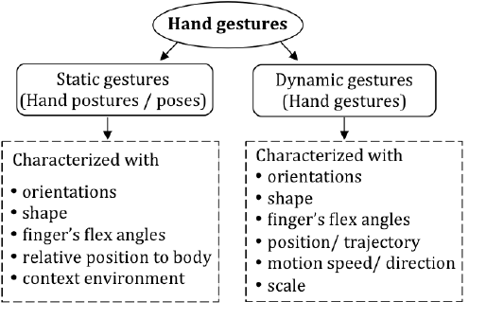
Fig 3.3 Different Gesture Recognition
3.3.1. Static and Dynamic Hand Gesture Recognition
Hand gestures are generally based on the orientation, shape, finger’s flex angles and yet, there are two types of gesture recognition: Static and Dynamic gestures. Each have their own unique applications. The Static Gesture recognition is able to take a frame of gesture as input, if and only the gesture is fixed for a while, to get a precise frame of pixels of the gesture given. The static provides a single gesture that is easy to comprehend for automation.

While the Dynamic Gesture Recognition can procure frames of trajectory objects with motion and direction. It has a gesture that moves in a trajectory with change in speed, position, signs. So, it would be hard to interpret them with simple techniques. They need to be selectively captured frame-to-frame or record a video with high quality and precision.

3.3.2 Distribution of Edge Pixels
In an edge map, Gestures have edges that are obtained by the Laplacian of Gaussian Mixture equation by zero crossing. The most commonly used feature is edge density. But the edge density measure does not give any spatial information of edge pixels. It is generally used for distinguishing convex hull regions from relatively clean background regions.

To model structure by spatial distribution of edge pixels, we propose an operator to map each pixel of an image patch into the number of edge pixels in its cross neighborhood. At first, edge detection is performed to obtain an edge map, and the number of edge pixels in each row y and each column x is calculated. Adaboost Learning of gesture Features based on the feature maps of gradient, stroke orientation, and edge distribution.

Image patches with fixed size (height 48 pixels, width 96 pixels) are collected and resized from images taken from the ICDAR-2011 robust reading competition to generate a training set for learning features of gestures. We generate positive training samples by scaling or slicing the ground regions, according to the aspect ratio of width w to height h.

It is used to calculate the image patches that contain fragments of defects. These fragments consist of three or more neighboring edge boundaries that have approximately equal heights and stay in horizontal alignment. But not all the satisfied neighboring edge boundaries. Thus, the classifier is applied to the image patches to determine whether they contain gestures.

3.3.3. GESTURE RECOGNITION
The Gestures waved in-front of a camera are captured frame by frame or a recording video is sampled to provide a matrix of pixels (i.e image). Then, the matrix of pixels are converted to bits by digitization of the image.

The sampled images are interpreted and by Continuously Adaptive Mean Shift algorithm, the gesture procured is analyzed for contours and localization of palm and finger tips or edges, image captured is converted to gray scale by background subtraction method. The edges are detected for localization of fingertips and counting to determine the corresponding gesture that manipulates gadget. The Region of Interest comprises the Convex hull and the edges in them. Despite of the defects as noise that would distort the image, filters help to maximize the data interpretation. The gesture images are stored by FIFO, First-In-First-Out as the first image procured is the first served and the gesture would point the linked device for manipulation or toggling. The Blind users can adjust their household gadgets the way they want and devices like Smart TV, electric fan, lighting at home, door locks, etc would be taken care of by themselves.

By CAMSHIFT Algorithm the image processing is done and it requires edge detection using Laplacian of Gaussian Equation:
As Laplace operator may detect edges as well as noise (isolated, out-of-range), it may be desirable to smooth the image first by a convolution with a Gaussian kernel of width
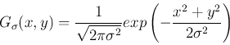

To suppress the noise before using Laplace for edge detection:
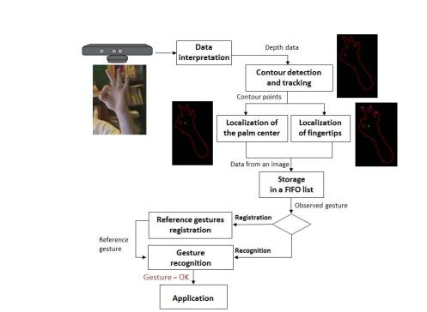
Fig 3.3.3 Gesture Recognition Algorithm Flowchart.

CHAPTER 4
PROJECT DESCRIPTION

4.1. BLOCK DIAGRAM
Power Supply

Raspberry Pi
Gestures
Camera
Relay Drive

Gadgets

USB Camera
Hand Gestures

USB Port

4.2. POWER SUPPLY SOURCE:

Regulator section

Filter
Circuit

Step Down
Transformer

Bridge
Rectifier

Fig 4.2.1.Power Supply
Automatic mains changeover switch for uninterrupted power supply is an integral part of the power control process, allowing smooth and immediate transfer of electrical current between multiple sources and the load. Here we are using two transformers TF1 (Main transformer) and TF2 (Backup transformer). The transfers switch senses when utility power is interrupted, and starts up the transformer TF2 which acts as a backup transformer. If the utility power remains absent, the transfer switch disconnects the load from the utility and connects it to the Transformer TF2, restoring electricity to the load. The transfer switch continues to monitor utility power, and when it is restored, switches the load from the Transformer TF2 back to the Main transformer TF1. Once the Transformer TF2 is disconnected, it goes through a cool-down routine and is automatically shut down.

The present system is designed around two transformers. One transformer (TF1) is used as the main supply and the other transformer (TF2) is used in the place of the generator (for demo purpose). These two transformers are connected with the relay which is controlled by the embedded controller. The loads are connected to the main line (TF1) and as well as to the TF2.

Initially TF1 is connected to the load, the loads run with this power. Due to any reason this power is interrupted, then it is identified by the controller and it immediately switches ON to the TF2 through the relay. The controller continuously monitors the TF1 (main line). When it finds the power on it again switches the loads connection to the main line.
A power supply is a device that supplies electric power to an electrical load. The term is most commonly applied to electric power converters that convert one form of electrical energy to another, though it may also refer to devices that convert another form of energy (mechanical, chemical, solar) to electrical energy. A regulated power supply is one that controls the output voltage or current to a specific value; the controlled value is held nearly constant despite variations in either load current or the voltage supplied by the power supply's energy source.
Every power supply must obtain the energy it supplies to its load, as well as any energy it consumes while performing that task, from an energy source. Depending on its design, a power supply may obtain energy from:
- Electrical energy transmission systems. Common examples of this include power supplies that convert AC line voltage to DC voltage.
- Energy storage devices such as batteries and fuel cells.
- Electromechanical systems such as generators and alternators.
- Solar power.
A power supply may be implemented as a discrete, stand-alone device or as an integral device that is hardwired to its load. Examples of the latter case include the low voltage DC power supplies that are part of desktop computers and consumer electronics devices.
4.3. REGULATED POWER SUPPLY
A regulated power supply is an embedded circuit, or stand alone unit, the function of which is to supply a stable voltage (or less often current), to a circuit or device that must be operated within certain power supply limits. The output from the regulated power supply may be alternating or unidirectional, but is nearly always DC (Direct Current). The type of stabilization used may be restricted to ensuring that the output remains within certain limits under various load conditions, or it may also include compensation for variations in its own supply source. The latter is much more common today.
The Power supply used here would be a power bank or a regulator that would provide 5V supply, <2.5 A Current supply for the raspberry pi.

4.4. PI Cam:
The e-CAM55_37x is the world's first MIPI CSI-2 camera interface reference design for TI's AM37x / DM37x processors and works with Logic PD’s Zoom™ DM3730 SOM-LV development Kit. E-CAM55_37x uses a 5 Mega Pixel auto focus camera module powered by Omni Vision’s OV5640 CMOS image sensor. This camera board is configured to provide MIPI-CSI-2 interface.

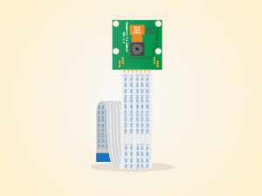
Fig: 4.4.1 PI Cam
The e-CAM55_37x can be directly plugged into the 2x240 Pin expansion socket provided on the Zoom™ DM3730 SOM-LV EVM. The software drivers provided by e-con Systems for this camera daughter card will configure OV5640 sensor and DM37x processor’s camera interface. This enables seamless 720p HD video streaming at 60fps through MIPI CSI-2 interface.

The camera board can be interfaced with any OMAP35x / AM37x / DM37x platform that expose the MIPI signals.

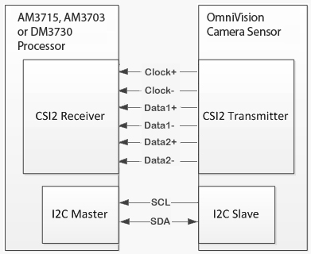
Fig: 4.4.2 Camera interfacing with controller
4.5. CSI:
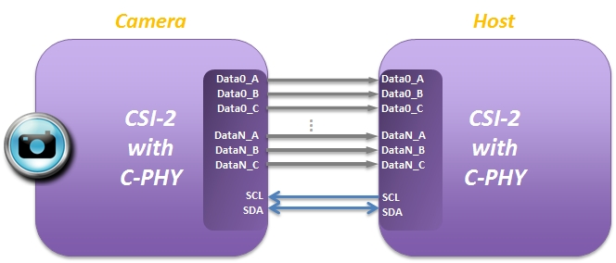

Fig: 4.5.1 CSI interfacing connecter
The Camera Serial Interface 2 Specification defines an interface between a peripheral device (camera) and a host processor (baseband, application engine). The purpose of this document is to specify a standard interface between a camera and a host processor for mobile applications.

4.6. SECURE DIGITAL (SD):
Secure Digital (SD) is a nonvolatile memory card used extensively in portable devices, such as mobile phones, digital cameras, GPS navigation devices, handheld consoles, and tablet computers. It is a family of solid-state storage media.
The Secure Digital standard was introduced in August 1999 as an improvement over Multi Media Cards (MMC). The Secure Digital standard is maintained by the SD Association (SDA). SD technologies have been implemented in more than 400 brands across dozens of product categories and more than 8,000 models.
The Secure Digital format includes four card families available in three different form factors. The four families are the original Standard-Capacity (SDSC), the High-Capacity (SDHC), the extended-Capacity (SDXC), and the SDIO, which combines input/output functions with data storage.[2][3][4] The three form factors are the original size, the mini size, and the micro size. Electrically passive adapters allow a smaller card to fit and function in a device built for a larger card.
There are many combinations of form factors and device families, although as of 2013, the prevailing formats are full- or micro-size SDHC and full or micro SDXC.
The SDA uses several trademarked logos to enforce compliance with its specifications and assure users of compatibility.

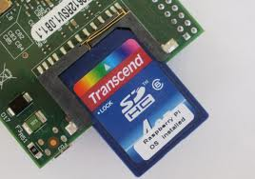
Fig: 4.6.1. SD card

4.7. RELAY MODULE
The relay module is a separate hardware device used for remote device switching. With it you can remotely control devices over a network or the Internet. Devices can be remotely powered on or off with commands coming from over a local or wide area network. You can control computers, peripherals or other powered devices from across the office or across the world.
The Relay module can be used to sense external On/Off conditions and to control a variety of external devices. The PC interface connection is made through the serial port.
The Relay module houses two SPDT relays and one wide voltage range, optically isolated input. These are brought out to screw-type terminal blocks for easy field wiring. Individual LED’s on the front panel monitor the input and two relay lines. The module is powered with an AC adapter.
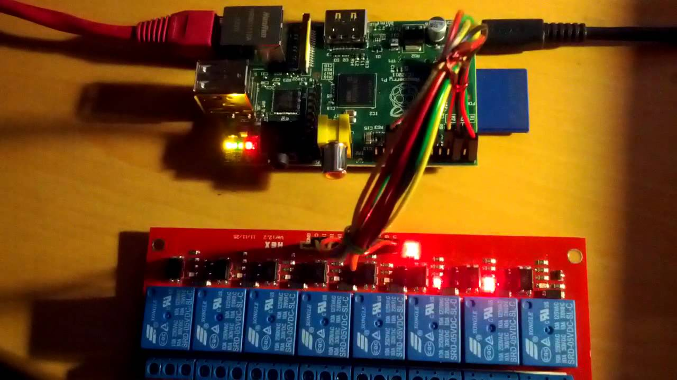
Fig 4.7 Relay Module
4.8 HOUSEHOLD GADGETS
The household gadgets that we are going to automate are the generally used fan, solenoid lock, electric bulb, Air Conditioners, etc. These amenities are triggered with each gesture we proposed and can be toggled with the users will. The necessary gadgets can be manipulated with gestures while others can be turned off.
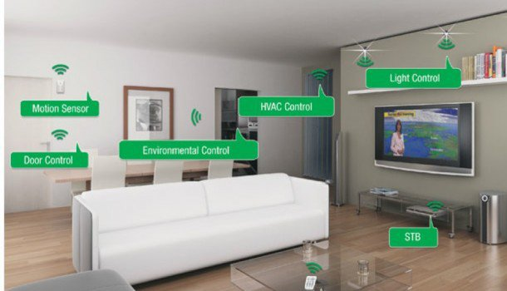
Fig 4.8 Household Gadgets

CHAPTER 5
RASPBERRY PI
5.1. INTRODUCTION
The Raspberry Pi Foundation designed this little board here, the Raspberry Pi, to address a lost generation of computer programmers and hardware engineers. So, this little board here is low cost, it's easily accessible, it's very simple to use. When you power it up you get a nice little desktop environment, it includes all of the things that you need to do to get started to learn programming. There's lots of information out there on the internet that you can take away and start programming code in to make things happen. It is possible to do everything with a Raspberry Pi. The real advantage of a Raspberry Pi as far as programming is concerned is the network port. This port will make it easier to connect to the Internet, which you’ll need to do to install some software. Any USB keyboard and mouse should work fine. Most SD cards should work, although there are a few that will cause problems. If you’re unsure, buy one from a Raspberry Pi online shop

The Raspberry Pi has a HDMI (high-definition multimedia interface) video output, but most monitors have VGA or DVI input. If at all possible, use a monitor that has DVI or HDMI input. HDMI-to-VGA converters are available, but they’re more expensive and can cause problems, so use them only if you have no other option. Most micro USB power supplies from reputable manufacturers should work; however, some cheap ones from no-name companies have caused problems, so if possible, don’t skimp too much on this. You could use a USB cable from a normal computer to power your Pi.Not all USB hubs are powered, so make sure that whatever one you get plugs into the mains electricity to get extra power. The only thing to say here is that if you do choose to get a USB webcam, make sure it’s compatible with the Raspberry Pi. There’s a partial list of working web cams at You’ll need to connect your Pi to the Internet to install the software. You can do this either by plugging your Pi into your router with a network cable or by using a USB wireless dongle, which will add Wi-Fi connectivity. Raspberry Pi is commonly available in the following models namely Model A, Model B and Model B+.

Model A has 256Mb RAM, only one USB. Model B has 512Mb RAM, Ethernet port, and 2 USB ports. It has a Broadcom BCM2835 system on a chip which includes an ARMl176JZF -S 700 MHz processor, Video Core IV GPU, and an SD card. The GPU is capable of Blue ray quality playback, using H.264 at 40MBits/s. It has a fast 3D core accessed using the supplied OpenGL ES2.0 and Open VG libraries. The chip specifically provides HDMI and there is no VGA support. Model B+ is similar Model B but it has more GPIO ports than Model B. The GPIO header has grown to 40 pins when compared to the 26 pin as in Model B. Model B+ has 4 USB 2.0 ports compared to 2 ports in the later. It also has better hot plug and over current behavior. The old friction-fit SD card socket has been replaced with a much nicer push-push micro SD version. By replacing linear regulators with switching ones the power consumption is reduced between 0.5W and 1W.The Raspberry Pi primarily uses Linux-kernel based operating systems. The foundation has provided Debian and Arch Linux ARM distributions here is used Python as the main programming language, with the support for BBC BASIC, C and Perl. Python was chosen as the main programming language, as it is easy to learn and a programming language that is suitable for real world applications. With the addition of Num Py, Sci Py, Matplotlib, IPython, and PyLab, Python can be used more effectively for computational mathematics as well as for the analysis of experimental data or control systems purposes.

5.2 HARDWARE:
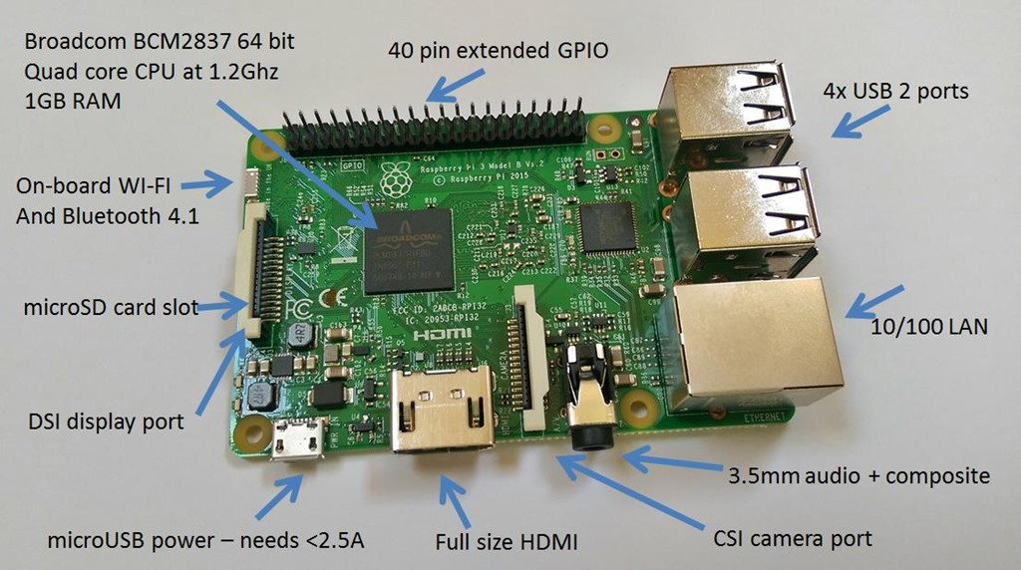
FIG: 5.2.1. RASBERRY PI 3

5.3. Processor:

The Broadcom BCM2837 SoC used in the Raspberry Pi is equivalent to a chip used in an old smart phone (Android or iPhone). While operating at 700 MHz by default, the Raspberry Pi provides a real world performance roughly equivalent to the 0.041 GFLOPS On the CPU level the performance is similar to a 300 MHz Pentium II of 1997-1999. The GPU provides 1 Gpixel/s or 1.5 of graphics processing or 24 GFLOPS of general purpose computing performance. The graphics capabilities of the Raspberry Pi are roughly equivalent to the level of performance of the Xbox of 2001. The Raspberry Pi chip, operating at 700 MHz by default, will not become hot enough to need a heat sink or special cooling. The SoC is stacked underneath the RAM chip, so only its edge is visible.

5.4.RAM:
On the older beta model B boards, 128 MB was allocated by default to the GPU, leaving 128 MB for the CPU. On the first 256 MB release model B (and Model A), three different splits were possible. The default split was 192 MB (CPU RAM), which should be sufficient for standalone 1080p video decoding, or for simple 3D, but probably not for both together. 224 MB was for Linux only, with just a 1080p frame buffer, and was likely to fail for any video or 3D. 128 MB was for heavy 3D, possibly also with video decoding (e.g. XBMC).

5.5. Peripherals:
Generic USB keyboards and mice are compatible with the Raspberry Pi

5.6 Networking:
Though the Model A and A+ do not have an 8P8C ("RJ45") Ethernet port, it can connect to a network by using an external user-supplied USB Ethernet or Wi-Fi adapter. On the model B the Ethernet port is provided by a built-in USB Ethernet adapter.

5.7. Over clocking:
Most Raspberry Pi devices can be over clocked to 800 MHz and some even higher to 1000 MHz. In the Raspbian Linux distro the overclocking options on boot can be done by a software command running "sudo raspi-config" without voiding the warranty, In those cases the Pi automatically shuttles the overclocking down in case the chip reaches 85 °C (185 °F), but it is possible to overrule automatic over voltage and overclocking settings (voiding the warranty). In that case, one can try putting an appropriately sized heat sink on it to keep the chip from heating up far above 85 °C.

5.8. Video:
The video controller is capable of standard modern TV resolutions, such as HD and Full HD, and higher or lower monitor resolutions and older standard CRT TV resolutions; capable of the following: 640×350 EGA; 640×480 VGA; 800×600 SVGA;1024×768 XGA;1280×720 720p HDTV;1280×768 WXGA variant; 1280×800 WXGA variant; 1280×1024 SXGA; 1366×768WXGA variant; 1400×1050 SXGA+;1600×1200 UXGA;1680×1050 WXGA+;1920×1080 HD TV; 1920×1200WUXGA. It can generate 576i and 480i composite video signals for PAL-BGHID, PAL-M, PAL-N, NTSC and NTSC-J.

5.9. Real-time clock:
The Raspberry Pi does not come with a real-time clock, which means it cannot keep track of the time of day while it is not powered on. As alternatives, a program running on the Pi can get the time from a network time server or user input at boot time. A real-time clock (such as the DS1307) with battery backup can be added via the I²C interface.

5.10 SOFTWARE

5.10.1 Operating systems:
The Raspberry Pi primarily uses Linux kernel-based operating systems. The ARM11 chip at the heart of the Pi is based on version 6 of the ARM. The current releases of several popular versions of Linux, including Ubuntu. It is not possible to run Windows on the Raspberry Pi. Raspbian (recommended) – Maintained independently of the Foundation; based on the ARM hard-float (armhf) Debian 7 'Wheezy' architecture port originally designed for ARMv7 and later processors (with Jazelle RCT/ThumbEE,VFPv3, and NEON SIMD extensions), compiled for the more limited ARMv6 instruction set of the Raspberry Pi. A minimum size of 4 GB SD card is required. There is a Pi Store for exchanging programs.
5.10.2 OpenCV
OpenCV is released under a BSD license and hence it’s free for both academic and commercial use. It has C++, C, Python and Java interfaces and supports Windows, Linux, Mac OS, iOS and Android. OpenCV was designed for computational efficiency and with a strong focus on real-time applications. Written in optimized C/C++, the library can take advantage of multi-core processing. Enabled with OpenCL, it can take advantage of the hardware acceleration of the underlying heterogeneous compute platform.
Open Source Computer Vision (OPENCV) Library is included for every computer vision as solution for image processing, Machine Learning and rarely known Deep Learning Concepts.
This tool helps to tamper with the very essence of data and provide a remarkable solution to every problem yet to be solved.

5.10.1 Python
An interpreted language, Python has a design philosophy which emphasizes code readability (notably using whitespace indentation to delimit code blocks rather than curly braces or keywords), and a syntax which allows programmers to express concepts in fewer lines of code than possible in languages such as C++ or Java.
Python is used in many fields like Data Science, Machine Learning, Raspberry Pi, Web development with Django Framework and many more. Python can use two modes: Interactive mode and Script mode, each has its own priority.
Other Programming Languages like C, C++, Java can also be used with Raspberry Pi. But, C and C++ has much faster Processing than Python, still python is applied mostly because it has more it helps in more easy coding than the rest.

CHAPTER 6
OPERATING SYSTEM
6.1 Raspbian OS
Raspbian is a free operating system based on Debian optimized for the Raspberry Pi hardware. An operating system is the set of basic programs and utilities that make your Raspberry Pi run. However, Raspbian provides more than a pure OS: it comes with over 35,000 packages, pre-compiled software bundled in a nice format for easy installation on your Raspberry Pi.
The initial build of over 35,000 Raspbian packages, optimized for best performance on the Raspberry Pi, was completed in June of 2012. However, Raspbian is still under active development with an emphasis on improving the stability and performance of as many Debian packages as possible. The Raspbian OS that we’re using is Raspbian Jessie that would support our system and mostly used platform in Raspberry Pi.

6.2. Raspberry Pi Config.txt Options
It is possible to modify various low level parameters of Raspberry Pi subsystems via a special file called config.txt.
As the Raspberry Pi doesn't have a conventional BIOS, the various system configuration parameters that would normally be kept and set using the BIOS are now stored in a text file named "config.txt".
The Raspberry Pi config.txt file is read by the GPU before the ARM core is initialized.
This file is an optional file on the boot partition. It would normally be accessible as /boot/config.txt from Linux, but from Windows (or OS X) it would be seen as a file in the accessible part of the card.

6.3. Raspberry Pi SD Card Performance
The SD card performance on the Raspberry Pi is very slow. Over time, it will be important to Raspbian to maximize to the extent possible the performance of the SD card media on the Raspberry Pi. For now, below is a collection of links that address this subject and will be explored further in the future. Installing an operating system on your Raspberry Pi We will begin using the Raspberry Pi on Sept 17, so we need to get ready. The first step is to install the operating system on the SD card included in your kit. You must complete this task before class on Sept 10. If you are unable to do this on your own, bring your SD card to class on Sept 10, and we’ll help you at the end of that class. Most general purpose processors require an operating system to manage their services, and the Raspberry Pi is no exception. We must install the Pi’s operating system before we can use it. Because the Raspberry Pi uses an SD card instead of a hard drive for its main memory, we will install the operating system on an SD card. Any formatted, class 4 (or higher), 4G minimum, SD card will do. We will use the Occidentalis operating system in this class. Occidentalis (from Rubus Occidental is--- the Latin name for raspberry), is Adafruit's version of Raspbian (i.e., the Linux operating system for the Raspberry Pi) configured for hardware support. The instructions below are a summary of those provided in Adafruit’s Raspberry Pi Tutorials, Lesson 1 for Windows platforms. If you are using a Mac or a Linux platform to write to your SD card, you need to go to the source, Adafruit’s Raspberry Pi Tutorials Lesson 1, for instructions. Before beginning you will need a computer (laptop or desktop) with a built-in SD card reader or an add-on USB SD card reader.
6.3.1. Instructions:
1. Download the zip file containing Raspbian Jessie v0.2 from Adafruit. Checking the SHA1 of your Occidental is zip file will assure that your download is good. If you want to do this (not usually required), download the File Checksum Integrity Verifier (FCIV) utility from Microsoft support and follow these instructions.
2. Unzip Occidentalisv02.zip to obtain the Raspbian Jessie image file.
3. To write the Raspbian Jessie image (Raspbian Jessie_v02.img) to your SD card, download one of two freeware programs: Win32 Disk Imager or Fedora ARM Installer and install it on your computer. I used Win32 Disk Imager.
4. Insert your SD card into your card reader, and start the card writer application installed in step 3 above. RUN THE CARD WRITER APPLICATION AS ADMINISTRATOR. Designate Occidentalis_v02.img as the image to write and the SD card drive as the destination, and then select write (or install, depending on the application).

CHAPTER 7
RESULT
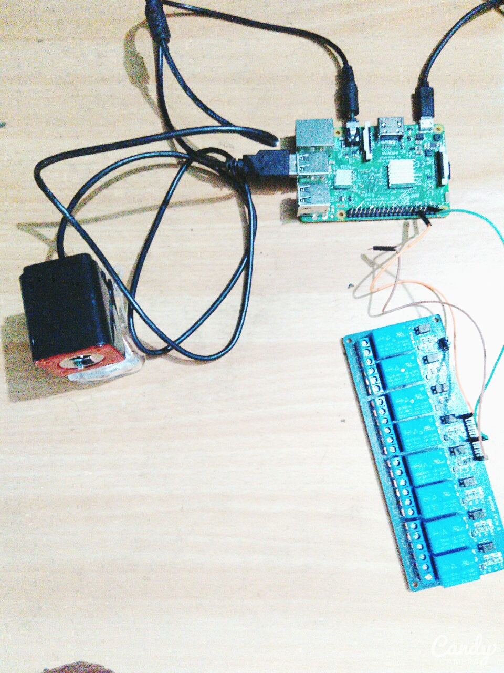
Fig 7. Result of Project

Our project as shown above helps to capture gestures with the webcam and do our image processing program on the Raspberry Pi. As we want to toggle the gadgets with a relay, the program triggers a relay for the gesture given as input to the System. The whole system is an ON/OFF controller that helps to toggle our household Gadgets with gestures as Stimulus.

CHAPTER 8
CONCLUSION

We have described a prototype system to automate our home with gesture controller for physically challenged persons. In order to solve the common aiming problem for blind users, we have proposed a motion-based method to detect the object of interest, while the blind user simply wave the hand for a couple of seconds. This method can effectively distinguish the object of interest from background or other objects in the camera view. To extract palm regions from complex backgrounds, we have proposed a novel finger localization algorithm based on models of stroke orientation and edge distributions. The corresponding feature maps estimate the global structural feature of gesture at every pixel. Block patterns project the proposed feature maps of an image patch into a feature vector. Adjacent character grouping is performed to calculate candidates of convex hull for gesture classification. An Ad boost learning model is employed to localize text in camera-based images. Off-the-shelf OCR is used to perform word recognition on the localized palm regions and transform into audio output for blind users. Our future work will extend our localization algorithm to process these gesture to stimulate the devices that are linked to it. Furthermore, we will address the significant human interface issues associated with gesture input to the system.

CHAPTER 9
FUTURE SCOPE
The Future Scope of our projects enlightens the way the gestures are used in many fields. In time, we may use WIFI as a tool to recognize gestures to automate our living Environment, where the frequency shift (Doppler effect) caused by gestures help to change our way of life. The gesture recognition can also be used for wheel chairs, Encryption Code for Authorization, Smart TVs Automobile Control and manufacturing industries.
The performance of Gesture Recognition is based on the Algorithm that we use and in the distant future, we would propose a better and faster algorithm to improve the performance of Gesture Recognition.

CHAPTER 10
REFERENCE
- http://www.raspberrypitutorials.yolasite.com
- Eyes Based Electric Wheel Chair Control System. International Journal of advanced computer science and Application 2011

- Hand gesture recognition system by Prof. Praveen D. Hasalkar1, Rohit S. Chougule2, Vrushabh B. Madake3, Vishal S. Magdum4 ,2015.

- Vision Based Hand Gesture Recognition for Human Computer Interaction by Radhika Bhatt, Nikita Fernandes , Archana Dhage, 2013.
- REAL TIME HAND GESTURE RECOGNITIONSYSTEM FOR DYNAMIC APPLICATIONS. Siddharth S. Rautaray1, Anupam Agrawal2
- Chao Hy Xiang Wang, Mrinal K. Mandal, Max Meng, and Donglin Li, “Efficient Face and Gesture Recognition Techniques for Robot Control”, CCECE, 1757-1762, 2003.
- Asanterabi Malima, Erol Ozgur, and Mujdat Cetin, “A Fast Algorithm for Vision-Based Hand Gesture Recognition for Robot Control”, IEEE International Conference on Computer Vision, 2006.
- Jagdish Lal Raheja, Radhey Shyam, Umesh Kumar and P Bhanu Prasad, “Real-Time Robotic Hand Control using Hand Gestures”, Second International Conference on Machine Learning and Computing, 2010.
- Gesture Controlled Robot using Kinect http://www.e-yantra.org/home/projects-wiki/item/180-gesture-controlled-robot-using-firebirdv-and-kinect
- OpenCV Library http://docs.opencv.org/

